Kevin Tavara

ECE-447-201

02.16.2021

Lab 1: Polling Input

**Introduction:** The purpose of this lab is to implement various ways to change the state of the led based on the input of the button. The delay used in this lab is polling the input or delaying the input by 0.25 seconds.

**Hardware Design:**

Brown/Orange wire (GND) connects to negative terminal of led.

Red wire (P2.6) connects to power rail on breadboard in series with the resistor

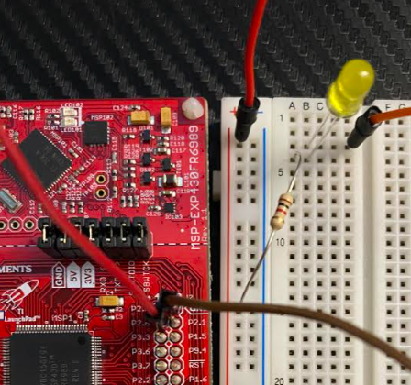

**Software Design:**

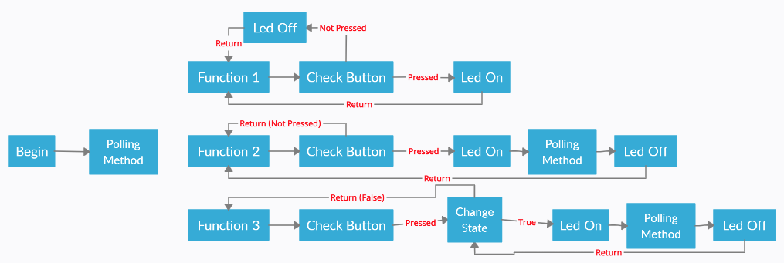

**Conclusions:** My lab operated as described in the lab description. The lab required at least 3 functions to implement, turn on when pressed, blink when pressed, negate state of blinking when pressed. The code is organized in sections and most is commented because otherwise they would conflict with one another but in the video, I will uncomment and comment each one and demonstrate. My button was not working well for the last part but the button did start and stop the blinking as described in the description.

**Questions:**

**1.** The delay for the asm is different because the asm will be processed immediately while the c code must be put into the compiler to change it from c to asm code. For this reason, asm is much quicker to run.

**2.** The formula is Y = X * (10 [μs]); X is amount of looping. One loop is 10 microseconds.

25000 * 10 microseconds = 0.25 [s]

**3.** I believe the delay does match my formula the noticeable difference is the blink lasts longer since the delay function is used between the statements to turn the led on and off.

**6.** Setting the break:

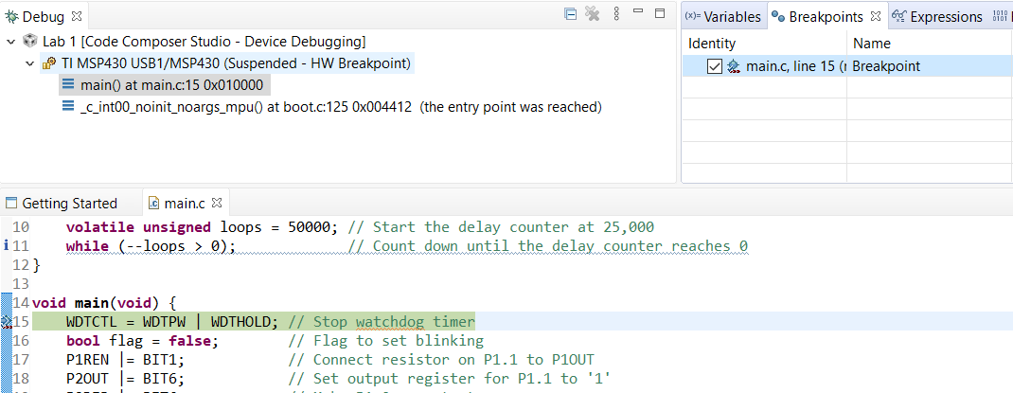

Stepping into delay function:

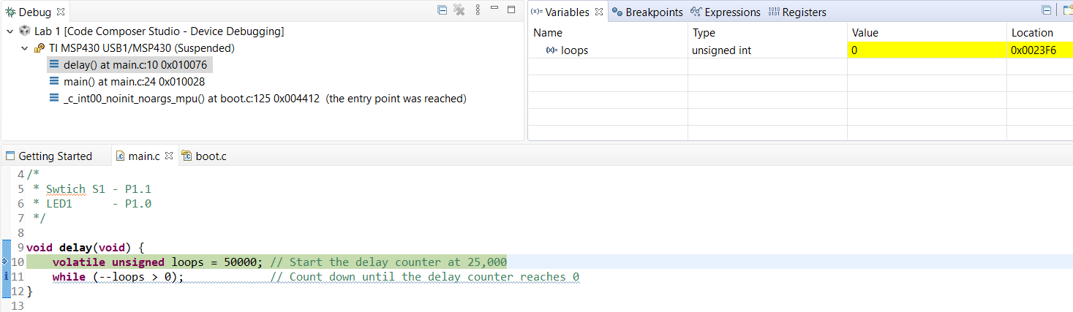

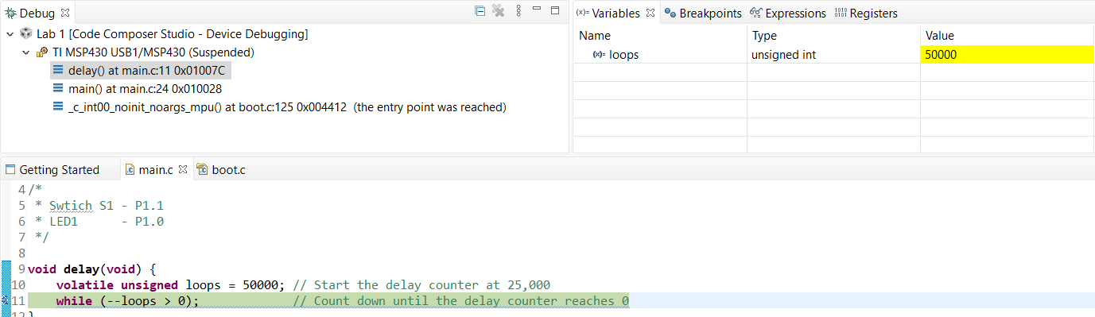

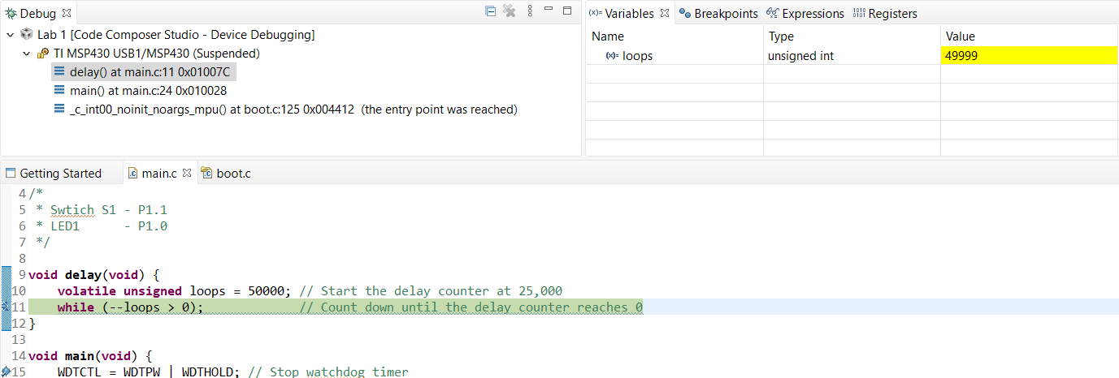

Step Return:

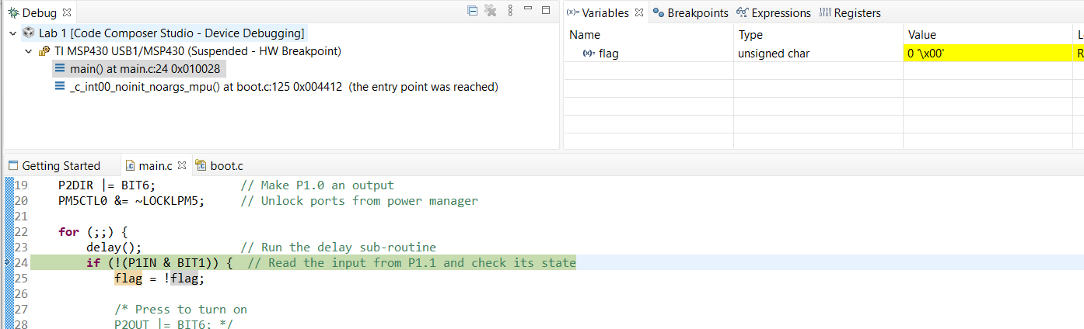

While the step into button is used to go to the method that is being called, the step return button is to get out of that method and return to the main to the line after the method was called.

**Demo Video:** [**https://youtu.be/pdMB6nZilaE**](https://youtu.be/pdMB6nZilaE)